Social Studies 10-1: Unit 2 Module
Historical Globalization
In this part of the course, you will be asked to ponder, research and analyze information so can can answer the following questions:
- What are the consequences of historical globalization (imperialism) on Aboriginal societies? (2.1)
- How can we exhibit a global consciousness with respect to the human condition? (2.2)
- What are our social responsibilities as global citizens? (2.3)
- What are the impacts of Eurocentrism?
Key Terms - PLEASE DEFINE!!!
- Imperialism
- historical globalization
- Mercantilism
- Capitalism
- grand exchange
- Industrial Revolution

10-1 Related Issue 2 Vocabulary

Use a dictionary, your textbook or the internet to understand and record the meanings of each of the following terms.

1. Cultural Contact:

2. Colonial:

3. World View:

4. Eurocentrism:

5. Capitalism:

6. Free Market:

7. Industrialization:

8. Imperialism/imperialistic:

9. Reserve:

10. Residential Schools **:

11. Indian Act:

12. Statement of Reconciliation:

13. Monopoly:

14. Globalization:

15. Motivator:

16. Mercantilism/mercantilist:

17. Protectionism:

18. Eurocentric:

19. Ethnocentrism:

20. Apartheid:

21. Social Darwinism:

22. Sovereignty :

23. Manifest Destiny
Foundations of Globalization
In this chapter, you will explore answers to the following questions:
- Why and how did globalization begin?
- How did the foundations of historical globalization affect people?
- How did the consequences of historical globalization affect people?
First, read Chapter 5 in the online textbook
Watch the video: Silk Road
Then, complete the assignment questions below:
1. Define the following words:

a. Historical Globalization

b. Mercantilism:

c. Capitalism:

d. Grand / Columbus Exchange:

FILL IN THE BLANKS

2. As early as the third century BCE, a fragile network of
linked Asia and Europe. Known as the

after the beautiful thread harvested from silkworms, the various routes provided a way of distributing many prized goods, such as

3. The First Peoples of the western hemisphere also developed complex trade routes, such as the
of the Pacific Northwest.

4. Describe each of the Three Rounds of the evolution of globalization in your own words.

5. Some economists and historians refer to Sheshabalaya’s so-called second round as
The beginning of this period is often identified as 1492, the year
made his first voyage to the Caribbean.

In O’Rourke and Williamson’s view, globalization began around
when low-cost goods from farms and factories poured into markets around the world—and access to these goods began to change the way

6. When Columbus sailed from
in 1492, his goal was to find a new route to
He never did reach China—but on October 1, 1492, his expedition landed on an island in the

7. Many Europeans regard Columbus as a
who “discovered” the
and started the era that is often called the

8. But not everyone views Columbus as a hero. When some American cities proposed
to mark October 12, 1492—the 500th anniversary of Columbus’s landing on Hispaniola
Erupted.

9. When
a German inventor, pioneered a
that used movable type, he set in motion changes that would have
effects on Europe—and the world. Gutenberg’s method was so revolutionary that is has been called the

10. How were books produced before Gutenberg’s invention?

11. In the centuries after the fall of Rome in 476 CE, European society was engulfed in
People often lived in
communities. Social status was often determined by
and social power was defined by the

12. At the same time, however, towns and cities were
Townspeople and city dwellers were often
Their knowledge and skill gave them new ways of accumulating wealth—and wealth became a measure of .

13. Their independence fostered a sense of individualism, a belief that people should be able to act freely. As a result, they often valued
and welcomed innovations such as

and new

14 As the middle class grew larger and more influential,
became even more important and Europeans began to look for ways to increase
by expanding trade.

15. In 1560, the population of London was

16.What three innovations are presented on page 121 as being important to the development of Europe?
1.

2.

3.

17. The European mercantilists of the 16th, 17th, and 18th centuries did not call themselves “mercantilists” because
Like many historical terms, the word “mercantilism” was coined to describe a way of
only after the mercantilist period was nearly over. The term “mercantilist” did not appear in English until

18. Once European countries established colonies, they encouraged settlers to

from their home country to the newly acquired lands. This emigration served a number of purposes. (List them below)

19. The Indigenous peoples of various continents faced difficult
when the imperialist powers colonized their lands. And no matter where the contact occurred, the outcome was
for Indigenous peoples.

20. Mexico, for example, Spanish soldiers led by

had defeated the extensive
by 1521. In North America, some First Peoples benefited from the
and the introduction of European tools and technologies—but these benefits did not last. As Europeans built
and began farming, First Peoples were forced out of their

21. Some estimates suggest that 75 to 90 percent of the Indigenous people of the Americas
may have died as a result of contact. Most of these deaths were the result of diseases contracted by people who had no
against European illnesses and infections.

22. Some Europeans, such as
were troubled by the destruction of Indigenous cultures. Unlike many Europeans, he believed that the Indigenous peoples were the
He tried to persuade Spanish authorities to change their policies and create communities where

23. One idea that Las Casas regretted was his suggestion that
be imported to work on the new
He had hoped mistakenly, that they would be

24.In ancient Israel, slaves were not expected to work on Saturdays, the
A slave who was permanently injured by an owner had to be
and the owner who killed a slave could be punished.

25. African slaves were considered ideal plantation workers because they were often
Slavery continued in some parts of the world until well into the
Slavery was less common in northern parts of a continent, where the climate would not allow
. Maintaining large numbers of slaves over long, cold northern winters was not

26. List some examples from the textbook of the products exchanged through the Grand/Columbus Exchange.

27. By 1750, European consumers were demanding more goods and industrial
were stepping forward to meet this demand by developing machines that could produce goods more
more

, and more
than ever before. This process started in Britain when the
was invented.

28. Until then, most manufacturing took place in people’s homes. In the textile industry, for example, spinners would work at home to make thread from raw wool or cotton. What is this old industry called?

29. As factories were built, cheap machine-made products gradually replaced hand-crafted goods—and traditional craftspeople were driven out of work. This new way of working—in factories—sparked dramatic

and
changes. The era when industry became mechanized has become known as the

30. What does IMPERIALISM mean?

31. How does it relate to or contribute to globalization?
What is Imperialism?
Watch the following video and then complete the assignment questions. Clink the blue link below!
Imperialism: Crash Course World History
John Green Crash Course: Imperialism

Directions: After you’ve watched the video “Imperialism: Crash Course World History,” answer the following questions.

- China
What foreign nations colonized? | How did the natives respond to the foreign presence? | What was the major outcome?

- Africa

What foreign nations colonized? | How did the natives respond to the foreign presence? | What was the major outcome?

- India
What foreign nations colonized? | How did the natives respond to the foreign presence? | What was the major outcome?

Part 2: Legacies of Historical Globalization - Colonial Activity In Africa
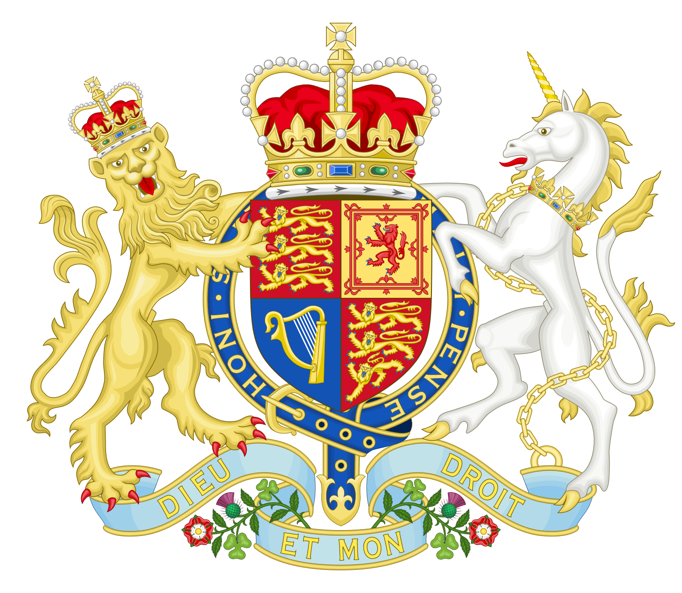
In this chapter, you will explore answers to the following questions:
- What are some legacies of historical globalization?
- How has cultural contact affected people?
- How has the exchange of goods and technologies affected people?
- How are the legacies of historical globalization continuing to affect people?
First, read all of Chapter 6 in the online textbook.
After you’ve read through Chapter 6, watch the following video called European Imperialism in Africa. Click on the blue link below!
EUROPEAN IMPERIALISM IN AFRICA
Once you’ve finished watching the video, answer the questions below:

European Imperialism in Africa
The Scramble for Africa
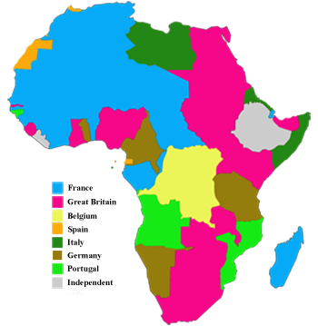

What happened during colonial imperialism in Africa?

What major figures or countries were involved with the Scramble for Africa?

Were the indigenous people in Africa treated fairly? Why or why not?

What reasons did Europeans have for coming into Africa?

How would you define imperialism in your own words?

Who was Joseph Conrad and what stance did he take on imperialism?

Were there any parts of Africa that were able to stay independent?

The Scramble for Africa: Part 2

Answer the following questions based on the Scramble for Africa cartoon and video.

Scramble for Africa

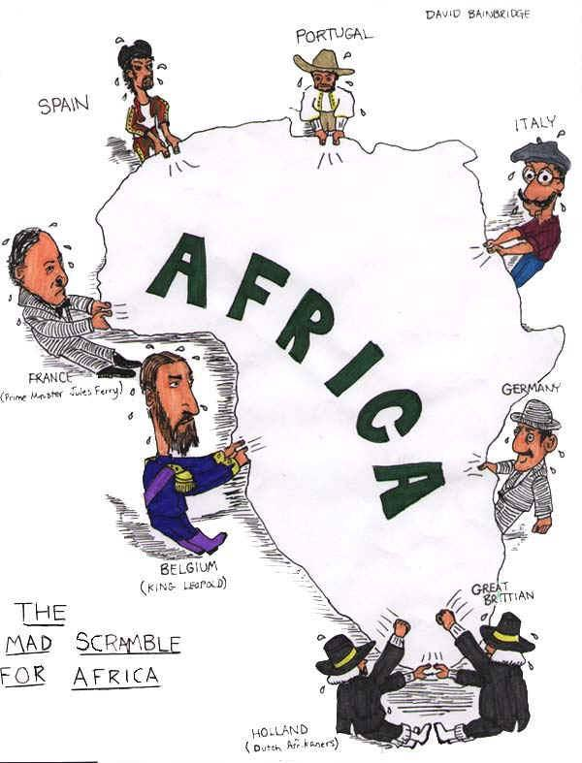

- According to the cartoon, which European countries were fighting for a position in Africa?

- How did the Berlin Conference lead to the situation shown in this cartoon?

AFRICA MAP COMPARISON

Examine the maps below, then answer the questions that follow.

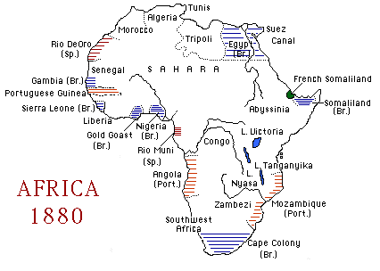

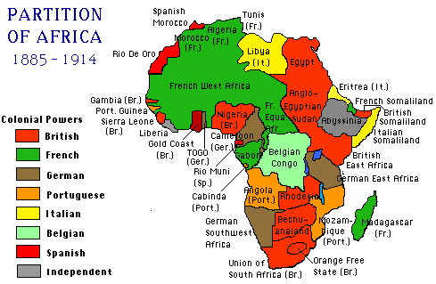

above maps from http://fresno.k12.ca.us/schools/s090/lloyd/imperialism.htm

1. What is the main difference between the 2 maps?

2. What part did the Berlin Conference play in the creation MAP 2?

3. What happened to the native African political entities by 1914?

4. According to Map 2-- Which 2 European countries held the most territory in Africa?

AFRICA POLITICAL DIVISIONS IN 1913
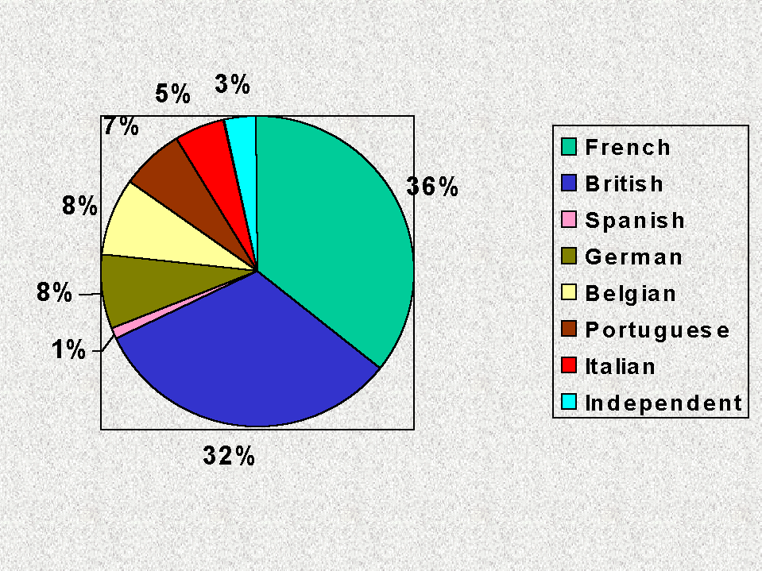
1. What percentage of Africa was colonized by 1913?

2. According to the graph, Which 2 European countries held the most territory in Africa? (did you get the same answer as #4 in the Map Comparison above?)

3. What percentage Africa was controlled by the rest of the countries (excluding the 2 countries mentioned in #2)?

4. Think about it: Would the information in MAP 2 and the pie chart above be the same if there had never been a Berlin Conference?

Link to today:
Compare MAP 2-- PARTITION OF AFRICA with the map of Africa from 1997 below

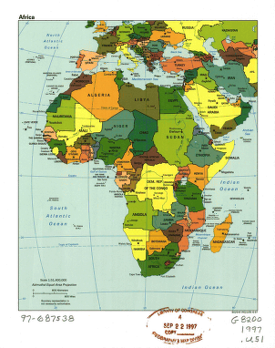


How did the Scramble for Africa in the 1800's and 1900's affect the current borders of Africa?

Part 3: Legacies of Historical Globalization in Canada
In Chapter 7, you will explore answers to the following questions:
- How did historical globalization affect Canada?
- What are some legacies of historical globalization in Canada?
- How has historical globalization affected Indigenous peoples in Canada?
- How do some legacies of historical globalization continue to affect Canada?
key terms - please review and define any terms you haven’t done previously!!
- Indian Act
- status Indian
- residential schools
- cultural mosaic

- multiculturalism
- cultural pluralism
- Quiet Revolution
Read Chapter 7 by clicking the link below!
Chapter 7 PDF link

A Sorry State (2012)
Meet the most apologized-to family in the country. Maybe in the entire world.
47 min. documentary, written and directed by Mitch Miyagawa
Winner of the 2013 Writers Guild of Canada Screenwriters Award for Documentary
Watch the film by click the blue link below:
A Sorry State

A Sorry State Film Questions
Documentary by Mitch Miyagawa
Filmmaker Mitch Miyagawa has the most apologized-to family in Canada, maybe even the world. But what do apologies mean to his parents, his young children and his country? Can saying “sorry” fix past atrocities and heal victims’ pain?

- What is your reaction to this film?

2. Name at least 3 historical events for which the Canadian government has apologized.

3. Does saying “Sorry” do any good? How do you feel about the apologies the government has made? Does it adequately address the wrongs that were done?

4. How do you feel about the point system that residential survivors had to add up in order to receive compensation from the government of Canada?

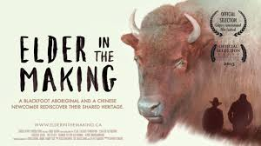
Two young urban dwellers, one a Blackfoot aboriginal named Cowboy and the other a Chinese-Canadian newcomer named Chris, embark on a spiritual journey across traditional Blackfoot territory.
Through thousands of years of ancient history guided by the wisdom of modern day elders, they find the beginnings of the long road to reconciliation between indigenous and non-indigenous people.
“Elder in the Making” is a feature documentary inviting all residents of North America to explore the tragic and hopeful history of their home. Through the journey of two unlikely travel companions, this film uncovers our responsibility as stewards of the land and of the generations yet to come.
Click on the blue link below to watch the documentary:
Elder In The Making

ELDER IN THE MAKING (2015)
Chris Hsiung, Producer/Director
Cowboy SmithX, Co-­‐Producer

BACKGROUND KNOWLEDGE:
Cowboy SmithX is a Blackfoot man from Piikani Nation. Chris Hsiung is a first generation Chinese-­‐Canadian raised in Calgary. Together they embark on a journey across Treaty 7 territory to learn about their common heritage and what it means to be an elder of value.

In addition to Reserves for several Aboriginal nations, it also encompasses the province of Alberta and the city of Calgary.

Read the following “Conversation Guide” for Alberta Treaties 6, 7 & 8
http://empoweringthespirit.ca/wp-content/uploads/2017/05/Alberta-Treaties-678-1.pdf

Answer the following questions:

- What was the role of the Indian Agent?
- Name 6 powers that the Indian Agent had over the life of First Nation people?
- Name one thing that made Treaty 6 different from other treaties?
- Name one thing that made Treaty 7 different from other treaties?

- Name one thing that made Treaty 8 different from other treaties?
- Name one myth that you thought was true and reflect on how you came to have that misconception.

Making Your Own Land Acknowledgment
Acknowledging territory is a way of showing respect for Indigenous people. It is the recognition of Indigenous presence both in the past and the present. Acknowledging land before a speech, during daily announcements and before assemblies, are essential to establishing healthy, reciprocal relations. These simple gestures are key to reconciliation.
Activity: Create your own acknowledgment for your treaty area in which you live in. Below is a template. Use the links below and this Conversation Guide to help you. Make it your own using your new knowledge of Alberta treaties.

“I wish to acknowledge that the land on which we gather is in Treaty (answer here) (treaty number) territory.
This is within and surrounding the traditional meeting grounds and home for many Indigenous Peoples, Including (answer here) (names of language groups). This is also home to the Métis communities of (answer here) (list communities). I also wish to acknowledge the Inuit people who join us in this area and bring with them a rich and beautiful culture from which we
learn. I want to acknowledge our Elders in this area who (answer here) ( list special contributions and role of Elders) in our communities. I also wish to honour the Elders, Knowledge Keepers and traditionalists who have gone before us and those who continue to walk with us today.”

Here are some links that might help you complete your land acknowledgment:
Metis Settlement Maps
https://metisarchitect.com/2015/07/27/introduction-the-alberta-metis-settlements/

https://www.settlementinvestcorp.com/
Role of an Elder
https://www.ictinc.ca/blog/aboriginal-elder-definition
Through centuries of interaction, First Nations view the Numbered Treaties as sacred. As an expression of this association, First Nations in Canada and members of the Federal Government will regularly meet to celebrate milestone anniversaries, exchange ceremonial and symbolic gifts, and discuss treaty issues. After so many acts of deception and dishonor by the Federal Government, why do the First Nations continue to celebrate these historic treaties?
https://en.wikipedia.org/wiki/Numbered_Treaties

Northwest Mounted Police: The North-­‐West Mounted Police (NWMP) was a Canadian police force. It was established in 1873, and in 1904 the name was changed to Royal Northwest Mounted Police (“Mounties”). http://www.militaryheritage.com/nwmp.htm

ROOTS

Like the vast majority of Canadians, Chris is a descendant of immigrants. He grew up thinking there was no history or culture before the Europeans came. Today, he realizes he is missing an important part of Canadian history and his own story as a resident of Treaty 7.

What do Chris and Cowboy have in common regarding their heritage?

Howard Zinn said that “If you don’t know your history, it is as if you never were born.” After viewing the documentary, what do you think Zinn’s statement means to Chris and Cowboy? Provide details (stated or inferred) from the film to support your answer.

Do YOU feel this way? Do you need to know your family’s history in order to feel whole and complete? Do you know the cultural traditions, language, and history of your ancestors? What does your name mean? What aspects of your heritage have been preserved through the generations, and what aspects have been lost? If you want to know more about your history and heritage, how would you go about doing that?

ADAPTATION
Cowboy goes on a journey to understand the history of his people and discovers many examples of cultural adaptation, beginning with the origin of his own name, Cowboy Smith. What does he discover?

Why was he named “Cowboy” and why “Smith”? Why did he add “X” to the end of his name,? What does the “X” mean, and why did he feel that it was important to make the name-­‐change legal? Compare this to the naming of African slaves…..or to name-­‐changes made to immigrants who entered the US via Ellis-­‐Island.

Were you surprised to know that Cowboy plays golf, the “game of the oppressor”? Were you surprised to find out that Cowboy was an actual ‘cowboy’ at one point in his life? Why were you surprised? Explain the “irony.”

Participating in golf and rodeo are examples of cultural “adaptations. ‘ What was happening historically that made it OK for people of aboriginal descent to participate in golf or rodeo while they were not welcomed into other public spaces?

How are our ideas about other cultural groups shaped? How did Hollywood shape and reinforce the stereotypical image of the North American Indians? Beyond Hollywood, in what other ways have the stereotypical images and ideas about Native Americans been perpetuated? Why would one culture do this to another culture? Where else is this happening in the world today?

THE “INDIAN PROBLEM”: REMOVAL, ASSIMILATION and GENOCIDE
Both men believe that they are foreigners in their own land because they have been cut off from their heritage through cultural assimilation. Cowboy, like many of Canada’s indigenous peoples, is re-­‐establishing his identity by educating himself about his past. The “X” in his name marks his missing history that was wiped away by generations of cultural genocide. To be an “elder of value” he must understand his past so that he can lead people into a more humane future.

Identify the political, economic, and cultural forces that led to the movement of the tribes onto reserves? Were these pressures the same in Canada as in the United States?

How does the rebuilt site of Fort Macleod exemplify: “History is how we want it to be seen, rather than how it really was.”?

ECOLOGY and INTERDEPENDENCE

This geography is also deeply intertwined with First Nations spiritual beliefs and with their identity. What did you learn from the film about Blackfoot spiritual traditions?

Ecosystems are interdependent systems. When one part of the system crashes, the other parts crash, as well. Explain the phrase, “The trauma of the past crashes into the present”—What does this mean? What aspects of the present culture have been affected by events of the past?

How have the discoveries of archaeologists and ecologists helped to illuminate the history and lifeways of the Blackfoot?

ELDERS
The documentary film you just viewed is entitled, Elder in the Making. Define the term “Elder.” What does the term “Elder” mean to you? Respond using this stem:

An Elder is

The film-maker, Chris Hsiung , concludes that Elders the world over share at least 4 common qualities. Explore each of these common attributes.

▪▪ An Elder is concerned about his/her community and future generations.

▪▪ An Elder continues to learn deeply and broadly.

▪▪ An Elder helps people learn from history and from life.

▪▪ An Elder is always an ‘Elder in the Making’.

Now watch Chris define what he thinks it means to be an Elder during this—the very first-­‐-­‐
“RedxTalk” (similar to a Ted Talk). https://vimeo.com/151964680

Cowboy considers himself an Elder-­‐in-­‐the Making and his purpose is to be a “ person of value” to all people, including people of aboriginal descent. Which members of the cast have achieved Elder status in your mind? Which cast members seem to be like Cowboy and Chris-­‐-­‐ Elders-­‐in-­‐the-­‐ Making?

What kind of “Elder in the Making” are YOU?

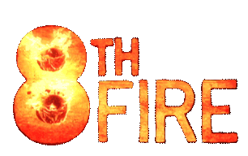

It's Time! challenges Canadians with this reality: if we don't improve our relationship with Aboriginal people, we will cripple our economy. Both the footage and the argument come in high definition.
First, watch The Fire Episode

8th Fire – It's Time (Episode 2)

Critical Thinking Challenges

- Think about historical events that have impacted your family or people of your ethnic group. Why is it important to learn about historical contexts?

- What is colonization, and how has colonization impacted Canada?

Viewing Questions
- In this episode, we meet Howie Miller and his family. 1. What experience did Miller have while growing up? 2. How has this impacted his identity as an Aboriginal man? 3. What does he do today?4. Why is this significant?

- Howie Miller’s son, Tyson Houseman, wants to be a role model for Aboriginal youth. 1. Why does he want this, and 2. How is he achieving this goal? 3. How has he explored his own Aboriginal identity?

- In approximately two minutes, Wab Kinew takes us on a walk through colonial history, exploring the events relevant to the relationship between Aboriginals and non-Aboriginals. 1. Describe this walk through history. What are the major events? 3. What historical documents are particularly significant?

- 1. Why was the Indian Act (1876) created by the Government of Canada? 2. What were some of the controls placed on Status Indians as a result of the Indian Act? 3. How did the repatriation of the Canadian Constitution in 1982 change the Indian Act?

- The Vancouver 2010 Olympics made a profound impact on many local First Nations, particularly those in the Whistler area. Discuss the impact on the Lil’wat Nation in terms of recognition, acknowledgement and economic gains. In terms of the rest of Canada, what is the significance of this fundamental relationship change?

- We meet Paul Martin, former Prime Minister of Canada, who also served for some time as Finance Minister. He is also a very successful businessman in his own right. Why does he think the non-Aboriginals and Aboriginals should partner financially?

- We meet Vanessa, a 32-year-old mother of six, who has just received a job offer from a financial institution. How has she moved beyond what some might have expected of her? Why is she participating in Nadya Kwandibens’s “Concrete Indian” photo series?

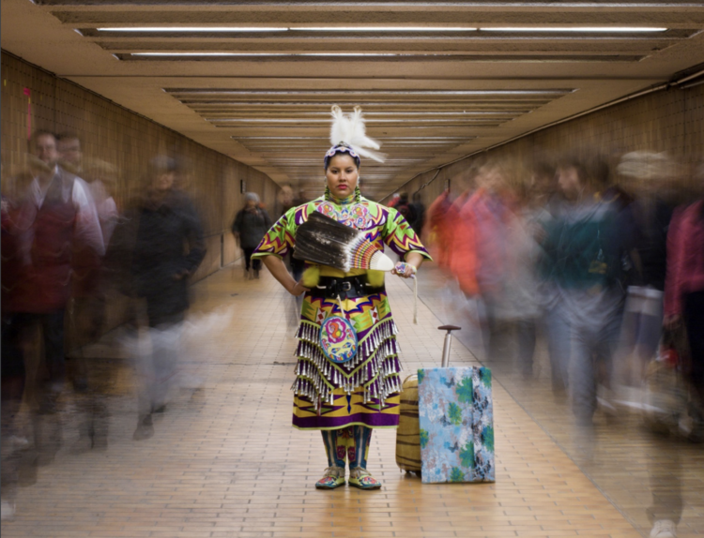
8. The cover of the 8th Fire guide below depicts one of Nadya Kwandiben’s photos.
What is she trying to achieve through the creation of the “Concrete Indian” series? How is the photo on the cover representative of the purpose of the series?

9. Throughout the episode, we see segments of a workshop presented by John Lagimodiere, owner of Aboriginal Consulting Services. What is his approach in his workshops? Initially, what are the reactions from participants? By the end of the workshop, how have their reactions changed?

10. Discuss the differences between the experiences of Native Americans in the United States during colonization and the experiences of Aboriginal people in Canada during the same time period.

11. The celebration shown during Treaty Day is symbolic. Discuss some of the events of that day, and why some First Nations continue to celebrate this day.

Chapter 8 – Connecting to Survivors

Read chapter 8. As you go, read the corresponding stories that align with the Legacies of Historical Globalization.

CHAPTER 8 PDF LINK HERE

Rwanda: https://www.un.org/africarenewal/web-features/i-was-tested-limit-%E2%80%94-rwanda-genocide-survivor

South Africa. Story and pictures: https://www.history.com/news/apartheid-policies-photos-nelson-mandela

Internment of Japanese Canadians: https://humanrights.ca/story/japanese-canadian-internment-and-the-struggle-for-redress

Global Income Inequality: https://www.oxfam.org/en/5-shocking-facts-about-extreme-global-inequality-and-how-even-it

Respond in a paragraph to one of the 4 links above with your overall thoughts on the Legacies of Historical Globalization.

